Source: <http://yann.lecun.com/exdb/publis/pdf/lecun-98.pdf>

*Below is not a paper summary; this is just the architecture of the LeNet model.*

<https://towardsdatascience.com/understanding-and-implementing-lenet-5-cnn-architecture-deep-learning-a2d531ebc342>

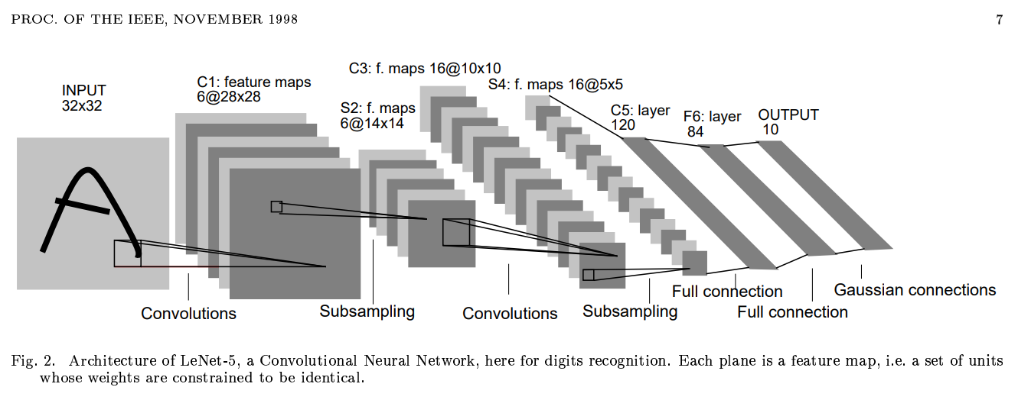

* Created for handwritten digit recognition on gray scale images
* MNIST image size: 28\*28
* Model input size: 32\*32, so padding is required
* Pixels had values in the range [0, 225], which were then normalized to [-0.1, 1.175]
* 1st layer: Conv. with 6 filters of size 5\*5, stride 1, and padding 2
* 2nd layer: Average pooling with pool size 2\*2, stride 2, and no padding
* 3rd layer: Conv. with 16 filters of size 5\*5, stride 1, and no padding
* 4th layer: Average pooling with pool size 2\*2, stride 2, and no padding
* 5th layer: Conv. with 120 filters of size 5\*5, stride 1, and no padding
* 6th layer: FC layer with 84 neurons
* 7th layer: FC layer with 10 neurons
* All conv. and FC layers used tanh activation function